# SOC JS Playback Engine – Service Utils - High Level Specifications

V.1.02

Author: marius alexandru

Contents

SOC JS Playback Engine – Service Utils - High Level Specifications 1

I. Service Utils – General Scope 2

II. Service Utils – Interfaces 3

III.A. Service Utils – Interfaces - Diagram 3

III.B. Service Utils – Interfaces – Description 3

# Service Utils – General Scope

**“ServiceUtils” Service** –

In addition to the hierarchy of SDK Services, the “ServiceUtils” Service is in charge to encapsulate the reusable code (like time/string/numbers functionality, html download/upload, files common processing functions).

So the “Utils” Services offers reusable code that is constructed on top of “SDK Services” an/or based on external libraries.

The Service offers dedicated interfaces for different utilities domains

Note: After the main core of the ServiceUtils was implemented, the ServiceUtils functionalities will be added whenever an Application Service will need them.

# Service Utils – Interfaces

## III.A. Service Utils – Interfaces - Diagram

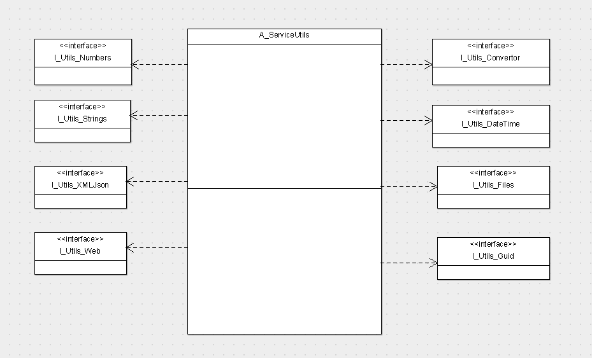

## III.B. Service Utils – Interfaces – Description

1. I_Utils_Convertors – this interface supplies different conversion reusable functionalities (like string/number conversion, etc).
2. I_Utils_DateTime – this interface supplies different date time reusable functionalities
3. I_Utils_Files – this interface supplies different reusable file functionalities (like: getFileExtension, getFilePath, etc)
4. I_Utils_Strings – this interface supplies different string functionalities (like : get the string between 2 string markers, get the string before/after one string marker etc..)
5. I_Utils_Numbers – this interface supplies different number functionalities
6. I_Utils_Guid – this interface supplies different Global Unique Identifier functionalities
7. I_Utils_XMLJson – this interface supplies different XML and Json reusable functionalities
8. I_Utils_Web – this interface supplies different reusable Web functionalities.